Investment Case 2

(Based on Python, Risk = Standard Variance(Yearly))

杨宸宇 2016301550186

1. The risk of these three assets show as followings:

|  |  |  |
| --- | --- | --- |
| **Risk** | | |
| **TMI** | **TKA** | **OLE** |
| **0.156294445** | **0.391078229** | **0.484089827** |

1. The risk resources of two companies are summarized in the following table:

|  |  |
| --- | --- |
| **Risk Resources** | |
| **ThyssenKrupp AG** | **Recent currency moves suggest some (material) risk of the potential for a demand shock** |
| **Deoleo SA** | **Raw material(weather)** |
| **Competitive conditions(the industry has seen large entry and exit in the last decade)** |
| **Demand in Spain and Italy is very price elastic** |
| **The leverage of the new strategy is high** |
| **Deoleo's banks may want to sell the equity stakes they acquired in the 2010 reorganization** |

1. Based on question 1, I predict that the 4th portfolio is riskier than any other one because the risk of OLE is the largest among all these four assets. However, when I calculate the risk of each portfolio, surprising to find that the risk of the 3rd portfolio is the biggest, which is different from my prediction. (Exhibit 1)

|  |  |  |  |
| --- | --- | --- | --- |
| **Risk** | | | |
| **Portfolio1** | **Portfolio2** | **Portfolio3** | **Portfolio4** |
| **0.101289363** | **0.109145308** | **0.115549591** | **0.109868009** |

As for reasons, I think it is because of the correlations of the four assets. Therefore, I calculate the correlations between them, showing as followings:

|  |  |  |  |  |
| --- | --- | --- | --- | --- |
| Correlation | Bond | TMI | TKA | OLE |
| Bond | 1 | -0.205479221 | -0.005322952 | 0.054261466 |
| TMI | -0.205479221 | 1 | 0.679991853 | 0.246788084 |
| TKA | -0.005322952 | 0.679991853 | 1 | 0.260611932 |
| OLE | 0.054261466 | 0.246788084 | 0.260611932 | 1 |

Through the table, we can easily find that the correlation between TMI and TKA is very high (0.679991853), which means the assets are not totally diversified and risk has not been eliminate because of it.

1. The regression plot for excess return of TKA(Y) and TMI(X) shows as following:



The regression summary for excess return of TKA(Y) and TMI(X) shows as following:

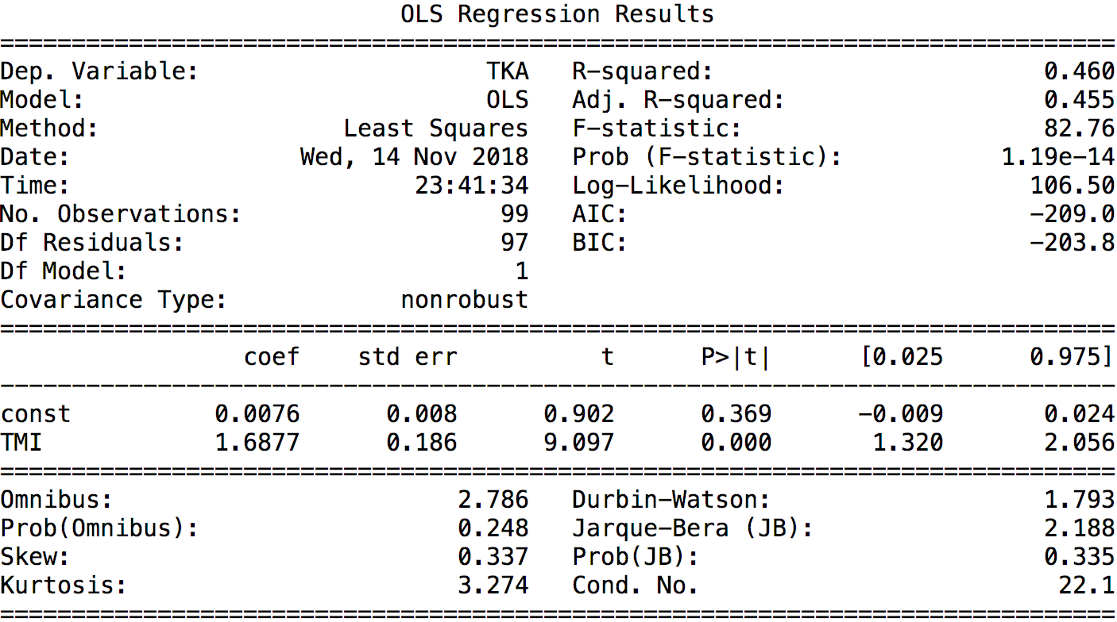

The regression plot for excess return of OLE(Y) and TMI(X) shows as following:



The regression summary for excess return of OLE(Y) and TMI(X) shows as following:

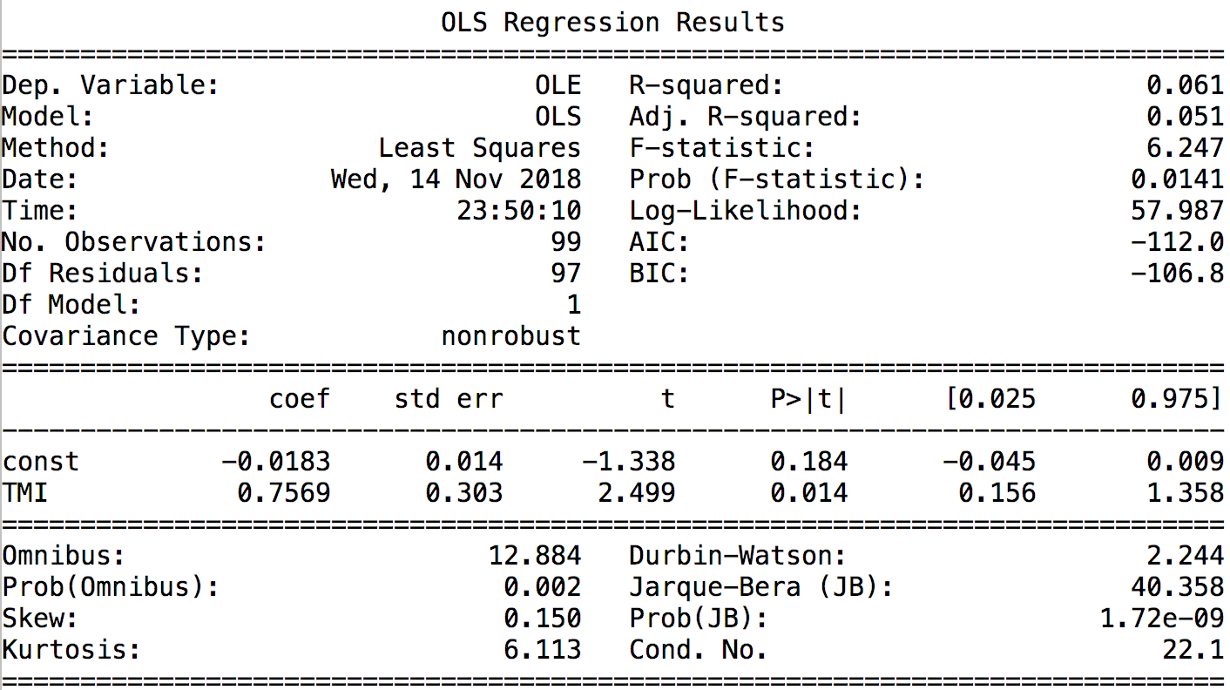

Therefore, the table of alpha, beta, R**2**, total risk, systematic risk and non-systematic risk of TKA and OLE shows as followings:

|  |  |  |  |  |  |  |
| --- | --- | --- | --- | --- | --- | --- |
|  | **Alpha** | **Beta** | **R-squared** | **Total Risk** | **Systematic Risk** | **Non-systematic Risk** |
| **TKA** | **0.007557** | **1.687714** | **0.460** | **0.391125609** | **0.265386998** | **0.287313389** |
| **OLE** | **-0.018298** | **0.756943** | **0.061** | **0.483873187** | **0.119026649** | **0.469005243** |

1. After building the single-factor model for TKA and OLE, I find the result match the brief summary of risk resources in Problem 2.

Firstly, considering TKA, I find the Beta (1.687714) is pretty high, which means it is sensitive to the market, and it can explain the huge recession of this stock along with the market index. Furthermore, the Alpha (0.007557) of TKA is pretty low, which helps to explain why its tendency of return was predicted accurately in the past few years. Also, the Systematic Risk (0.265386998) can explain this result, for it grows as auto and steal section develops. In Problem 2, I summarized that the main risk of this firm is from the material risk for a demand shock, and we can see it seems significant due to the value of Non-systematic Risk (0.287313389), which is larger than Systematic Risk (0.265386998).

Secondly, as for OLE, given the products of this company are ordinary consumptions in daily life, the risk of this firm will be lower than many of other firms in the market and of course, the Beta (0.756943) is lower than the average of the whole market as well. And the low Beta can explain why the price of the stock is pretty still while most others are falling extremely in the crisis. Then we can take a view of Non-systematic Risk (0.469005243), which is high. It is because of the great competition, the high leverage of the strategy, the high elastic of demand and some other reasons that cannot be explained by the market index.

1. Based on Problem 4, we can explain the Problem 2 more specifically, we were surprised to find that the risk of portfolio 4 is lower than portfolio 2. However, we can find the Beta of TKA (1.687714) is much larger than this of OLE (0.756943), which means the correlation of TKA and market is larger than this of OLE and market. Also, we can see that the Non-systematic Risk of TKA (0.082940) is lower than this of OLE (0.135390). Therefore, the total risk of portfolio 3 are supposed to be higher than portfolio 4.
2. Because of the small portion of assets except bonds and market index, I predict the Beta will be close to the portion of TMI, which means the Benchmark is 0.6, Portfolio 1 is 0.65, Portfolio 2 is 0.7， Portfolio 3 is a little larger than 0.65 and Portfolio 4 is a little larger than 0.65 but less than Portfolio 3.

Then I use OLS to analyze such 5 portfolios, and the results are as following (The OLS report are in the Appendix Exhibit 2):

|  |  |  |  |  |  |  |
| --- | --- | --- | --- | --- | --- | --- |
|  | **Alpha** | **Beta** | **R-squared** | **Total Risk** | **Systematic Risk** | **Non-systematic Risk** |
| **Benchmark** | **-1.08E-19** | **0.6** | **1** | **0.094347851** | **0.094347851** | **3.73067E-17** |
| **Portfolio1** | **-8.13E-20** | **0.650** | **1** | **0.102210172** | **0.102210172** | **2.01615E-17** |
| **Portfolio2** | **-1.08E-18** | **0.700** | **1** | **0.110072493** | **0.110072493** | **3.48736E-17** |
| **Portfolio3** | **3.78E-04** | **0.734385705** | **0.985** | **0.116369638** | **0.115479522** | **0.014365669** |
| **Portfolio4** | **-9.15E-04** | **0.687847173** | **0.955** | **0.110674414** | **0.108161505** | **0.023450262** |

Then the functions are showing as followings:

${r_{benchmark}=-1.08{*10}^{-19}+0.6*r}_{TMI}+ϵ$

${r_{portfolio1} =-8.13{*10}^{-20}+0.65*r}_{TMI}+ϵ$

${r_{portfolio2} =-1.08{*10}^{-18}+0.7*r}_{TMI}+ϵ$

${r_{portfolio3} = 3.78{*10}^{-4}+0.734385705*r}_{TMI}+ϵ$

${r_{portfolio4} =-9.15{*10}^{-4}+0.687847173*r}_{TMI}+ϵ$

1. The Alpha of portfolio 3 is positive, but not really significantly, which means the real return of portfolio 3 is higher than its expected return, it means we can earn some extra money beyond the portion connected to excess return of market index. Take Systematic Risk (0.115479522) and Non-systematic Risk (0.014365669) into consideration, we can find that the systematic risk contributes to the most of the risk, therefore, alpha may come from the fast development of steal and auto section, which is because of the policy of the country.

However, we can also find most alphas are not noticeable positive, which means most of the excess returns of these portfolios can be explained by the growing or depression of the financial market.

1. After removing the data in 2008, I use OLS to analyze such 5 portfolios, and the results are as following (The OLS report are in the Appendix Exhibit 3):

|  |  |  |  |  |  |  |
| --- | --- | --- | --- | --- | --- | --- |
|  | **Alpha** | **Beta** | **R-squared** | **Total Risk** | **Systematic Risk** | **Non-systematic Risk** |
| **Benchmark** | **-4.87E-18** | **0.6** | **1** | **0.0798096** | **0.0798096** | **1.71122E-17** |
| **Portfolio1** | **-6.02E-18** | **0.650** | **1** | **0.0864604** | **0.0864604** | **2.88971E-17** |
| **Portfolio2** | **-6.22E-18** | **0.700** | **1** | **0.0931112** | **0.0931112** | **3.42781E-17** |
| **Portfolio3** | **7.84E-05** | **0.739686216** | **0.984** | **0.099220513** | **0.098390101** | **0.012810076** |
| **Portfolio4** | **-1.32E-03** | **0.705617593** | **0.937** | **0.097002054** | **0.093858429** | **0.024494769** |

Then the functions are showing as followings:

${r_{benchmark}=-4.87{*10}^{-18}+0.6*r}_{TMI}+ϵ$

${r_{portfolio1} =-6.02{*10}^{-18}+0.65*r}_{TMI}+ϵ$

${r_{portfolio2} =-6.22{*10}^{-18}+0.70*r}_{TMI}+ϵ$

${r_{portfolio3} = 7.84{*10}^{-5}+0.739686216*r}_{TMI}+ϵ$

${r_{portfolio4} =-1.32{*10}^{-3}+0.705617593*r}_{TMI}+ϵ$

Compare the results with Problem 7, we can easily find the portfolio 1~3 nearly have no changes, however the Non-Systematic risk of Portfolio 3 decreases (0.012810076), and 4 increases (0.024494769), which reflects that TKA is more comprehensible by the market than OLE, especially when the Crisis happened and the market index decreased violently. Plus, we can see the Beta of Portfolio 4 increases (from 0.687847173 to 0.705617593), it can be explained by the Crisis when necessaries stay still while the market index decreased considerable. Therefore, when we take apart the data of this period, its trend can be explained by the financial market more comprehensive.

Also, we can find the general performances of these portfolios by taking apart the data in 2008 when the Crisis happened. And from this point of view, we can draw a conclusion that Portfolio 3 can earn a little more money beyond the market tendency while others have negative alphas. Furthermore, the Portfolio 3 is more closely connected to market than any other assets because of the highest Beta (0.739686216). Last but not least, The Portfolio 4 can distribute more risk because its Non-systematic Risk (0.024494769) has the biggest part of contribution of Total risk (0.097002054) among all portfolios.

**Appendix**

**Exhibit 1: Return of Different Portfolios**

|  |  |  |  |  |  |  |  |  |
| --- | --- | --- | --- | --- | --- | --- | --- | --- |
| Date | Bond | TMI | TKA | OLE | Portfolio1 | Portfolio2 | Portfolio3 | Portfolio4 |
| 31/1/2006 | 0.20% | 3.72% | 23.56% | 3.00% | 2.49% | 2.66% | 3.66% | 2.63% |
| 28/2/2006 | 0.21% | 2.09% | 1.14% | -1.68% | 1.43% | 1.53% | 1.48% | 1.34% |
| 31/3/2006 | 0.21% | 2.09% | 12.21% | 3.23% | 1.43% | 1.53% | 2.03% | 1.58% |
| 28/4/2006 | 0.21% | 0.67% | 9.74% | -0.43% | 0.51% | 0.53% | 0.99% | 0.48% |
| 31/5/2006 | 0.23% | -5.29% | 2.34% | -2.36% | -3.36% | -3.63% | -3.25% | -3.49% |
| 30/6/2006 | 0.23% | 0.53% | -0.15% | 2.42% | 0.43% | 0.44% | 0.41% | 0.53% |
| 31/7/2006 | 0.24% | 1.61% | 2.36% | 4.27% | 1.13% | 1.20% | 1.24% | 1.33% |
| 31/8/2006 | 0.25% | 2.63% | -2.93% | -0.17% | 1.80% | 1.92% | 1.64% | 1.78% |
| 29/9/2006 | 0.26% | 2.00% | 0.23% | -1.18% | 1.39% | 1.48% | 1.39% | 1.32% |
| 31/10/2006 | 0.27% | 3.59% | 9.21% | 2.89% | 2.43% | 2.59% | 2.88% | 2.56% |
| 30/11/2006 | 0.28% | -0.34% | 0.52% | 8.76% | -0.12% | -0.15% | -0.11% | 0.30% |
| 29/12/2006 | 0.28% | 3.85% | 22.44% | -5.02% | 2.60% | 2.78% | 3.71% | 2.34% |
| 31/1/2007 | 0.30% | 2.11% | 3.85% | 6.40% | 1.48% | 1.57% | 1.65% | 1.78% |
| 28/2/2007 | 0.30% | -2.04% | 2.36% | 5.26% | -1.22% | -1.34% | -1.12% | -0.97% |
| 30/3/2007 | 0.30% | 2.59% | 0.30% | 4.64% | 1.79% | 1.90% | 1.79% | 2.01% |
| 30/4/2007 | 0.31% | 3.36% | 6.86% | 1.30% | 2.29% | 2.44% | 2.62% | 2.34% |
| 31/5/2007 | 0.32% | 2.52% | 9.15% | -3.91% | 1.75% | 1.86% | 2.19% | 1.54% |
| 29/6/2007 | 0.32% | -0.76% | 1.51% | 4.00% | -0.38% | -0.44% | -0.32% | -0.20% |
| 31/7/2007 | 0.33% | -3.36% | -6.39% | -0.62% | -2.07% | -2.25% | -2.40% | -2.12% |
| 31/8/2007 | 0.32% | -1.21% | 4.75% | -0.48% | -0.67% | -0.75% | -0.45% | -0.71% |
| 28/9/2007 | 0.31% | 0.30% | 3.84% | -3.89% | 0.30% | 0.30% | 0.48% | 0.09% |
| 31/10/2007 | 0.32% | 2.87% | 2.91% | 0.14% | 1.98% | 2.11% | 2.11% | 1.97% |
| 30/11/2007 | 0.31% | -4.95% | -11.99% | 0.00% | -3.11% | -3.37% | -3.72% | -3.12% |
| 31/12/2007 | 0.31% | -1.55% | -5.12% | -0.71% | -0.90% | -0.99% | -1.17% | -0.95% |
| 31/1/2008 | 0.31% | -11.66% | -11.01% | -0.71% | -7.47% | -8.07% | -8.04% | -7.52% |
| 29/2/2008 | 0.31% | -0.87% | 15.96% | 3.60% | -0.46% | -0.52% | 0.33% | -0.29% |
| 31/3/2008 | 0.30% | -4.06% | -4.90% | -3.19% | -2.53% | -2.75% | -2.79% | -2.71% |
| 30/4/2008 | 0.31% | 5.50% | 11.11% | -1.51% | 3.68% | 3.94% | 4.22% | 3.59% |
| 31/5/2008 | 0.32% | -0.18% | 7.62% | 3.06% | -0.01% | -0.03% | 0.36% | 0.13% |
| 30/6/2008 | 0.35% | -10.17% | -8.14% | 2.80% | -6.49% | -7.01% | -6.91% | -6.37% |
| 31/7/2008 | 0.34% | -2.13% | -10.32% | -6.41% | -1.27% | -1.39% | -1.80% | -1.60% |
| 31/8/2008 | 0.34% | 1.68% | -4.45% | 0.15% | 1.21% | 1.28% | 0.97% | 1.20% |
| 30/9/2008 | 0.27% | -11.40% | -37.38% | -11.76% | -7.32% | -7.90% | -9.20% | -7.92% |
| 31/10/2008 | 0.16% | -13.42% | -30.54% | -9.00% | -8.67% | -9.35% | -10.20% | -9.13% |
| 30/11/2008 | 0.15% | -7.10% | 6.40% | 8.06% | -4.56% | -4.92% | -4.25% | -4.17% |
| 31/12/2008 | 0.11% | -3.86% | 20.00% | -3.65% | -2.47% | -2.67% | -1.48% | -2.66% |
| 31/1/2009 | 0.09% | -3.37% | -8.16% | -16.45% | -2.16% | -2.33% | -2.57% | -2.99% |
| 28/2/2009 | 0.07% | -9.49% | -11.09% | -15.79% | -6.14% | -6.62% | -6.70% | -6.94% |
| 31/3/2009 | 0.05% | 2.10% | -6.80% | -36.87% | 1.38% | 1.49% | 1.04% | -0.46% |
| 30/4/2009 | 0.06% | 13.68% | 22.03% | -14.45% | 8.91% | 9.59% | 10.01% | 8.19% |
| 31/5/2009 | 0.06% | 4.11% | 11.09% | -13.66% | 2.69% | 2.90% | 3.24% | 2.01% |
| 30/6/2009 | 0.05% | -1.23% | -1.78% | -7.77% | -0.78% | -0.85% | -0.87% | -1.17% |
| 31/7/2009 | 0.04% | 9.15% | 21.74% | 3.78% | 5.96% | 6.42% | 7.05% | 6.15% |
| 31/8/2009 | 0.03% | 5.16% | 9.46% | 3.36% | 3.36% | 3.62% | 3.84% | 3.53% |
| 30/9/2009 | 0.04% | 2.82% | 0.38% | -8.54% | 1.85% | 1.99% | 1.86% | 1.42% |
| 31/10/2009 | 0.04% | -2.29% | -7.77% | -39.11% | -1.47% | -1.59% | -1.87% | -3.43% |
| 30/11/2009 | 0.04% | 0.81% | 11.26% | -9.98% | 0.54% | 0.58% | 1.10% | 0.04% |
| 31/12/2009 | 0.03% | 6.14% | 8.60% | 18.38% | 4.00% | 4.31% | 4.43% | 4.92% |
| 31/1/2010 | 0.03% | -2.58% | -11.42% | 17.81% | -1.67% | -1.80% | -2.24% | -0.78% |
| 28/2/2010 | 0.02% | -0.50% | 0.52% | -11.82% | -0.32% | -0.34% | -0.29% | -0.91% |
| 31/3/2010 | 0.03% | 7.28% | 9.62% | 9.23% | 4.74% | 5.11% | 5.22% | 5.20% |
| 30/4/2010 | 0.03% | -1.13% | -3.32% | -19.11% | -0.72% | -0.78% | -0.89% | -1.68% |
| 31/5/2010 | 0.02% | -5.86% | -10.62% | -14.43% | -3.80% | -4.10% | -4.33% | -4.52% |
| 30/6/2010 | 0.02% | -0.70% | -7.20% | -5.24% | -0.45% | -0.48% | -0.81% | -0.71% |
| 31/7/2010 | 0.03% | 4.92% | 11.34% | 5.53% | 3.21% | 3.45% | 3.77% | 3.48% |
| 31/8/2010 | 0.03% | -1.58% | -4.84% | -1.75% | -1.02% | -1.10% | -1.26% | -1.11% |
| 30/9/2010 | 0.04% | 3.49% | 10.95% | -38.46% | 2.28% | 2.46% | 2.83% | 0.36% |
| 31/10/2010 | 0.06% | 2.51% | 10.04% | 51.93% | 1.65% | 1.77% | 2.15% | 4.25% |
| 30/11/2010 | 0.05% | -1.52% | 12.17% | -20.26% | -0.97% | -1.05% | -0.36% | -1.99% |
| 31/12/2010 | 0.04% | 5.52% | 4.58% | 44.44% | 3.60% | 3.88% | 3.83% | 5.82% |
| 31/1/2011 | 0.06% | 1.47% | -2.86% | -35.10% | 0.98% | 1.05% | 0.83% | -0.78% |
| 28/2/2011 | 0.06% | 2.26% | 1.48% | 5.19% | 1.49% | 1.60% | 1.56% | 1.75% |
| 31/3/2011 | 0.08% | -3.54% | -4.05% | -4.93% | -2.27% | -2.45% | -2.48% | -2.52% |
| 30/4/2011 | 0.09% | 2.80% | 7.71% | -5.19% | 1.85% | 1.99% | 2.23% | 1.59% |
| 31/5/2011 | 0.09% | -1.01% | 6.05% | -6.25% | -0.62% | -0.68% | -0.33% | -0.94% |
| 30/6/2011 | 0.10% | -3.01% | 7.54% | -11.67% | -1.92% | -2.08% | -1.55% | -2.51% |
| 31/7/2011 | 0.08% | -2.75% | -13.65% | -23.58% | -1.76% | -1.90% | -2.45% | -2.94% |
| 31/8/2011 | 0.05% | -10.46% | -22.83% | -18.52% | -6.78% | -7.31% | -7.93% | -7.71% |
| 30/9/2011 | 0.03% | -4.87% | -22.18% | -12.12% | -3.16% | -3.40% | -4.27% | -3.76% |
| 31/10/2011 | 0.03% | 7.66% | 14.03% | 25.86% | 4.99% | 5.37% | 5.69% | 6.28% |
| 30/11/2011 | 0.01% | -1.46% | -9.11% | 17.81% | -0.95% | -1.02% | -1.40% | -0.06% |
| 31/12/2011 | 0.01% | 1.89% | -7.01% | 0.00% | 1.23% | 1.33% | 0.88% | 1.23% |
| 31/1/2012 | 0.02% | 4.13% | 25.38% | 6.98% | 2.69% | 2.90% | 3.96% | 3.04% |
| 29/2/2012 | 0.01% | 3.91% | -6.13% | -3.26% | 2.55% | 2.74% | 2.24% | 2.38% |
| 31/3/2012 | 0.01% | -0.43% | -8.50% | -4.49% | -0.28% | -0.30% | -0.70% | -0.50% |
| 30/4/2012 | 0.01% | -2.18% | -4.07% | -18.82% | -1.41% | -1.52% | -1.62% | -2.36% |
| 31/5/2012 | 0.01% | -6.90% | -25.28% | -8.70% | -4.48% | -4.83% | -5.75% | -4.92% |
| 30/6/2012 | 0.01% | 4.68% | -4.40% | 3.17% | 3.05% | 3.28% | 2.82% | 3.20% |
| 31/7/2012 | 0.00% | 4.01% | 16.76% | -3.08% | 2.61% | 2.81% | 3.44% | 2.45% |
| 31/8/2012 | 0.00% | 1.85% | 5.99% | 9.52% | 1.20% | 1.30% | 1.50% | 1.68% |
| 30/9/2012 | 0.00% | 0.92% | 5.18% | 2.90% | 0.60% | 0.64% | 0.86% | 0.74% |
| 31/10/2012 | 0.00% | 0.68% | 5.64% | -7.04% | 0.44% | 0.48% | 0.72% | 0.09% |
| 30/11/2012 | 0.00% | 1.94% | -11.56% | -7.58% | 1.26% | 1.36% | 0.68% | 0.88% |
| 31/12/2012 | 0.00% | 1.54% | 14.10% | -9.84% | 1.00% | 1.08% | 1.71% | 0.51% |
| 31/1/2013 | 0.01% | 2.72% | 1.07% | 7.27% | 1.77% | 1.91% | 1.82% | 2.13% |
| 28/2/2013 | 0.00% | 1.03% | -3.45% | -5.08% | 0.67% | 0.72% | 0.50% | 0.42% |
| 31/3/2013 | 0.00% | 1.25% | -8.25% | -7.14% | 0.81% | 0.87% | 0.40% | 0.46% |
| 30/4/2013 | 0.00% | 1.26% | -12.99% | 1.92% | 0.82% | 0.88% | 0.17% | 0.92% |
| 31/5/2013 | 0.00% | 1.20% | 11.46% | 15.09% | 0.78% | 0.84% | 1.35% | 1.53% |
| 30/6/2013 | 0.01% | -5.27% | -1.62% | -13.11% | -3.42% | -3.69% | -3.50% | -4.08% |
| 31/7/2013 | 0.00% | 5.11% | 7.51% | 7.55% | 3.32% | 3.58% | 3.70% | 3.70% |
| 31/8/2013 | 0.01% | -0.68% | -2.79% | 19.30% | -0.44% | -0.47% | -0.58% | 0.53% |
| 30/9/2013 | 0.00% | 4.41% | 11.67% | 17.65% | 2.87% | 3.09% | 3.45% | 3.75% |
| 31/10/2013 | 0.00% | 3.83% | 6.24% | 5.00% | 2.49% | 2.68% | 2.80% | 2.74% |
| 30/11/2013 | 0.01% | 0.94% | 2.71% | 19.05% | 0.61% | 0.66% | 0.75% | 1.57% |
| 31/12/2013 | 0.01% | 1.03% | -8.44% | -6.00% | 0.67% | 0.72% | 0.25% | 0.37% |
| 31/1/2014 | 0.01% | -1.60% | 7.41% | 5.32% | -1.04% | -1.12% | -0.67% | -0.77% |
| 28/2/2014 | 0.01% | 4.89% | 3.32% | -20.20% | 3.18% | 3.43% | 3.35% | 2.17% |
| 31/3/2014 | 0.01% | -1.05% | -1.10% | 10.13% | -0.68% | -0.73% | -0.73% | -0.17% |

**Exhibit 2: OLS for Benchmark and 4 Portfolios**

**Benchmark**

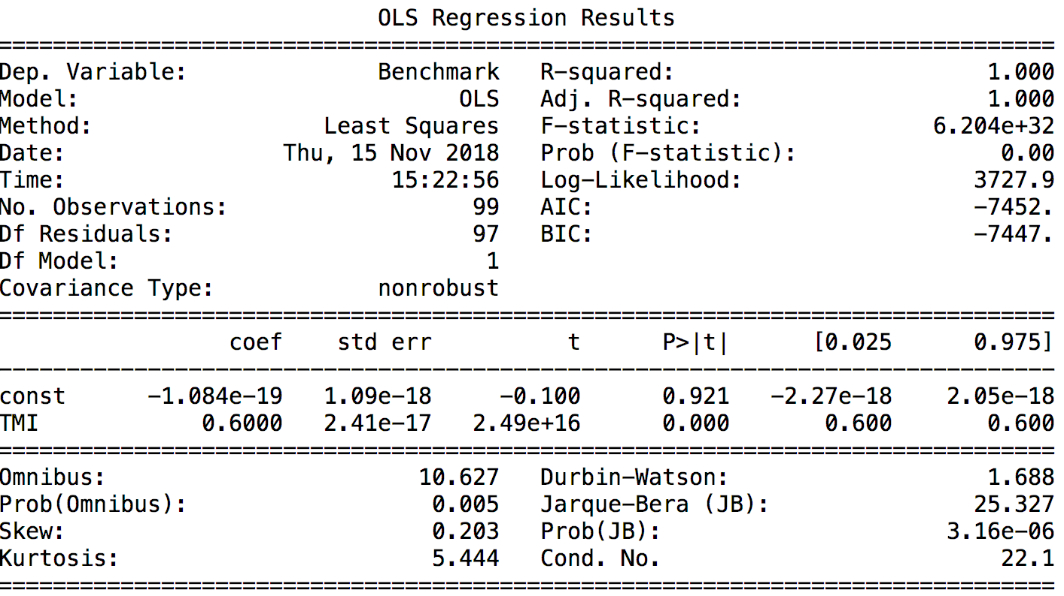

**Portfolio 1**

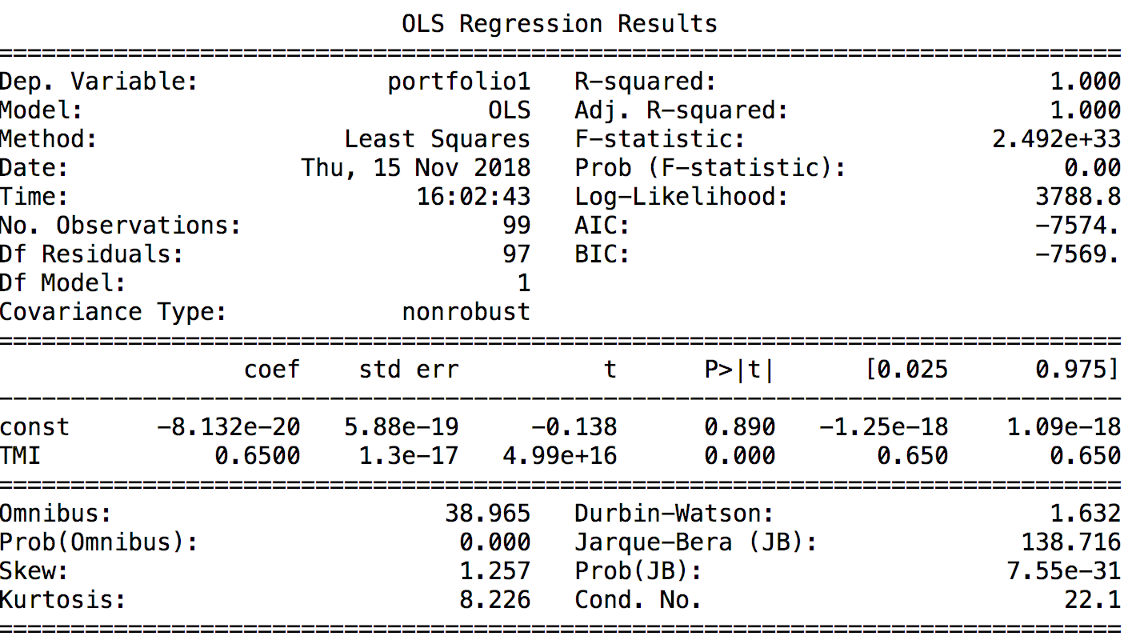

**Portfolio 2**

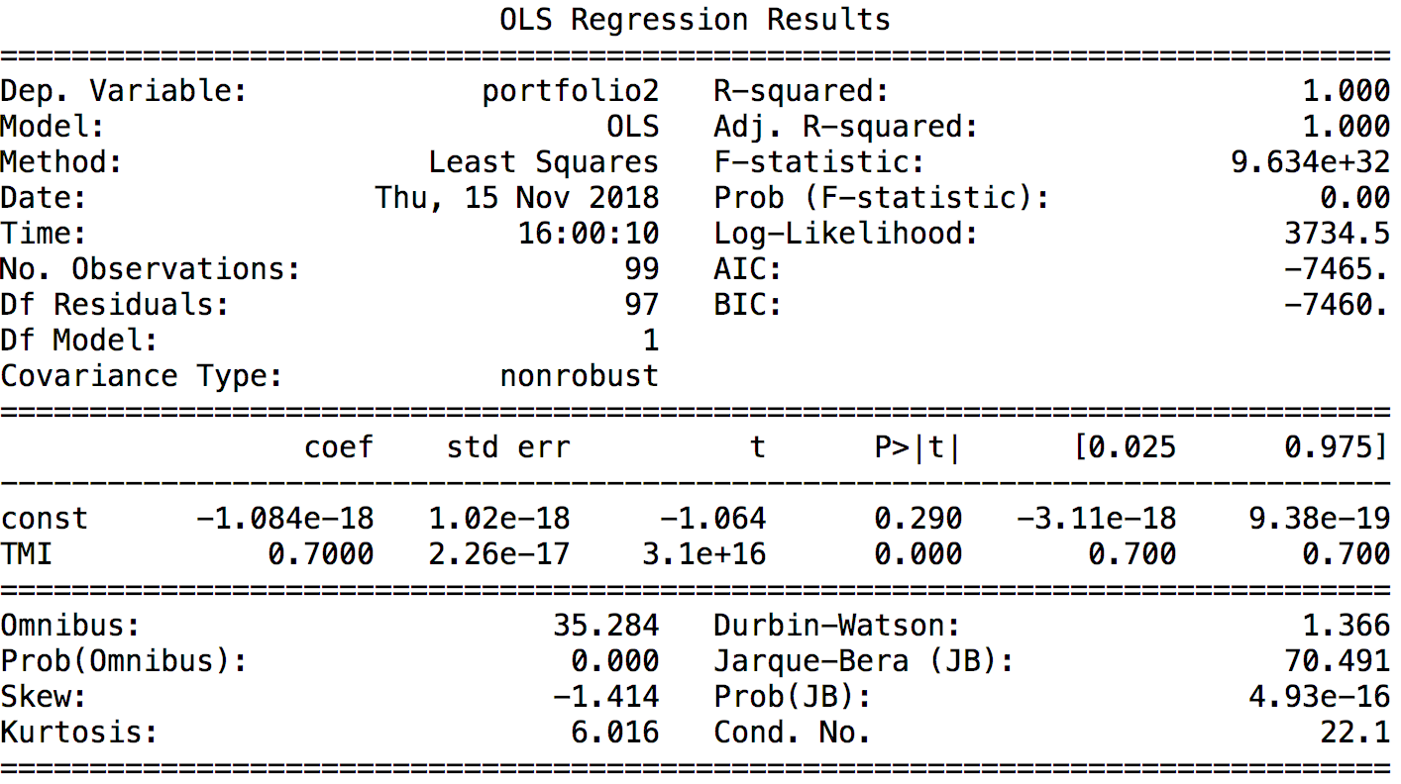

**Portfolio 3**

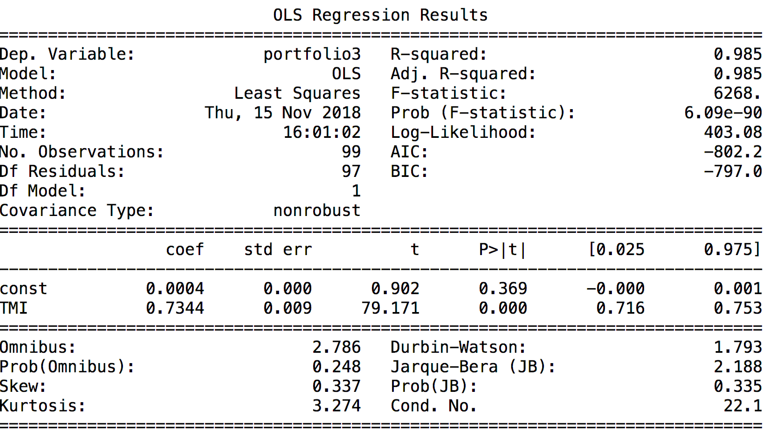

**Portfolio 4**

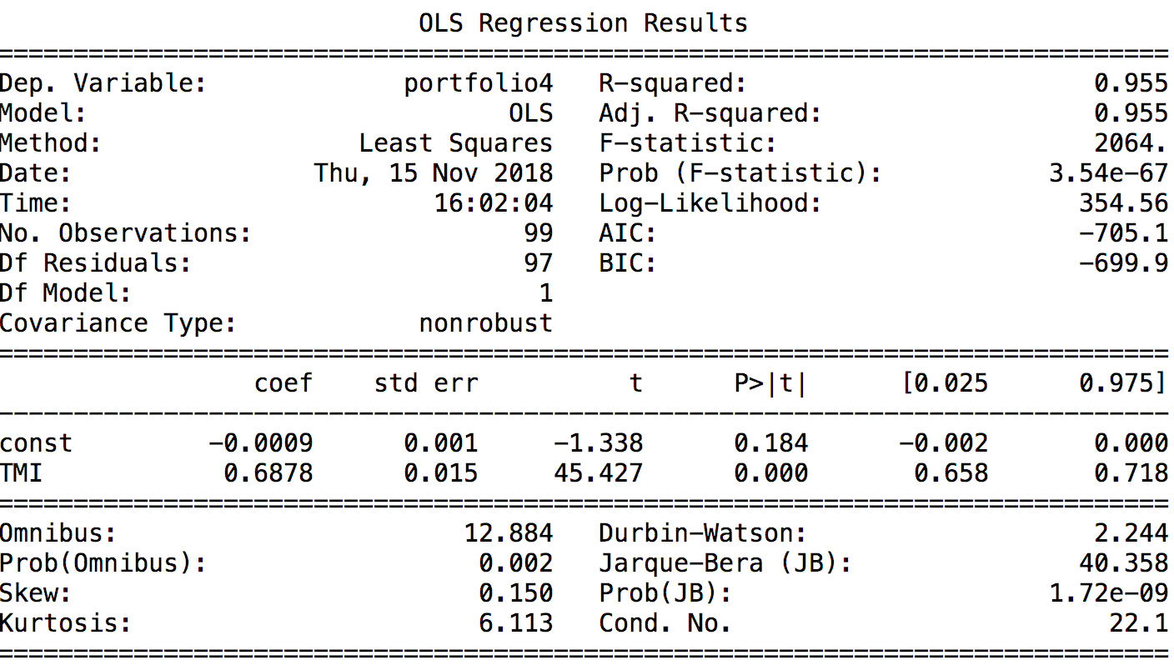

**Exhibit 3: OLS for Benchmark and 4 Portfolios**

**(without data in 2008)**

**Benchmark**

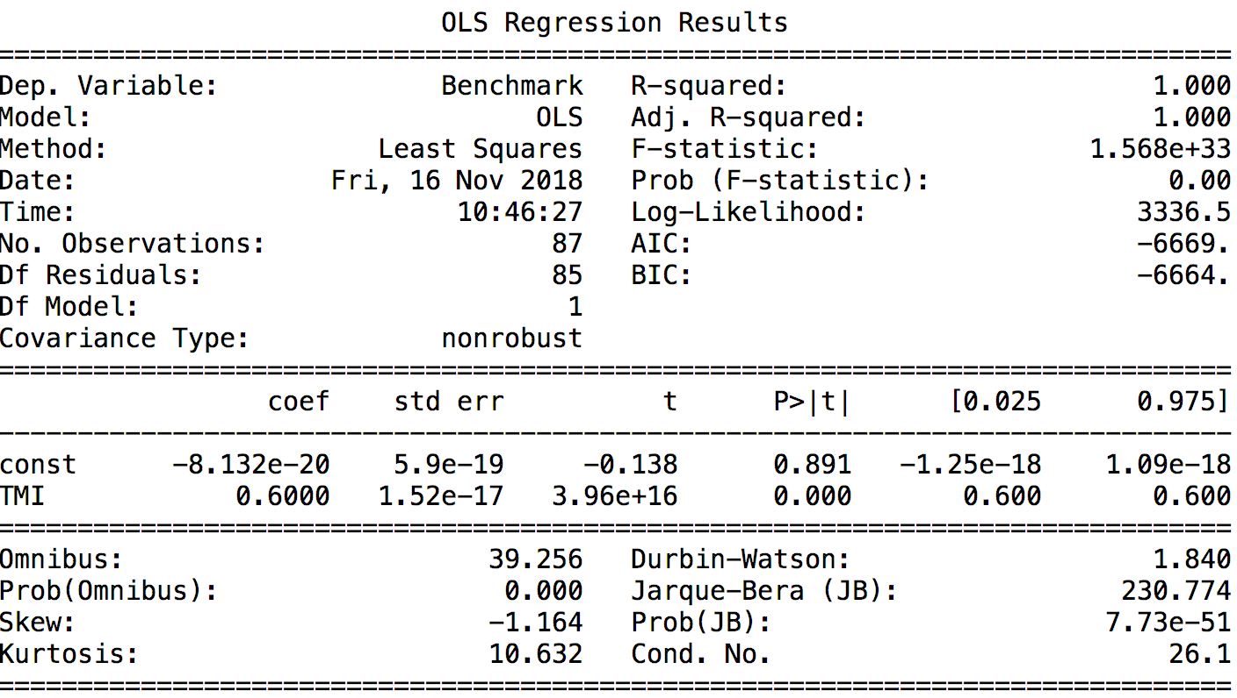

**Portfolio 1**

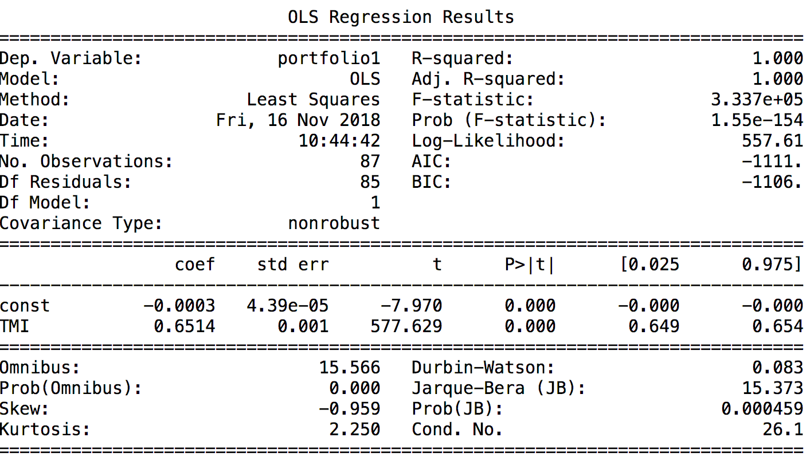

**Portfolio 2**

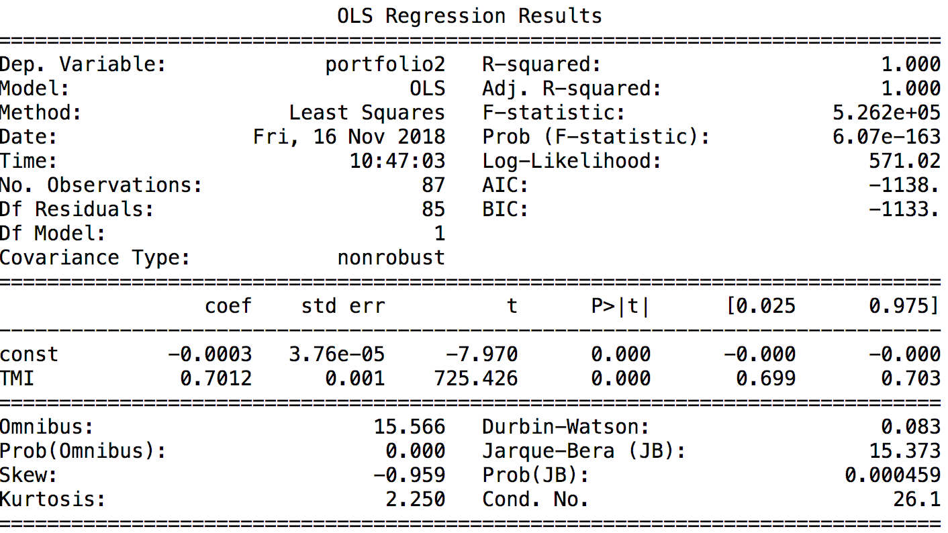

**Portfolio 3**

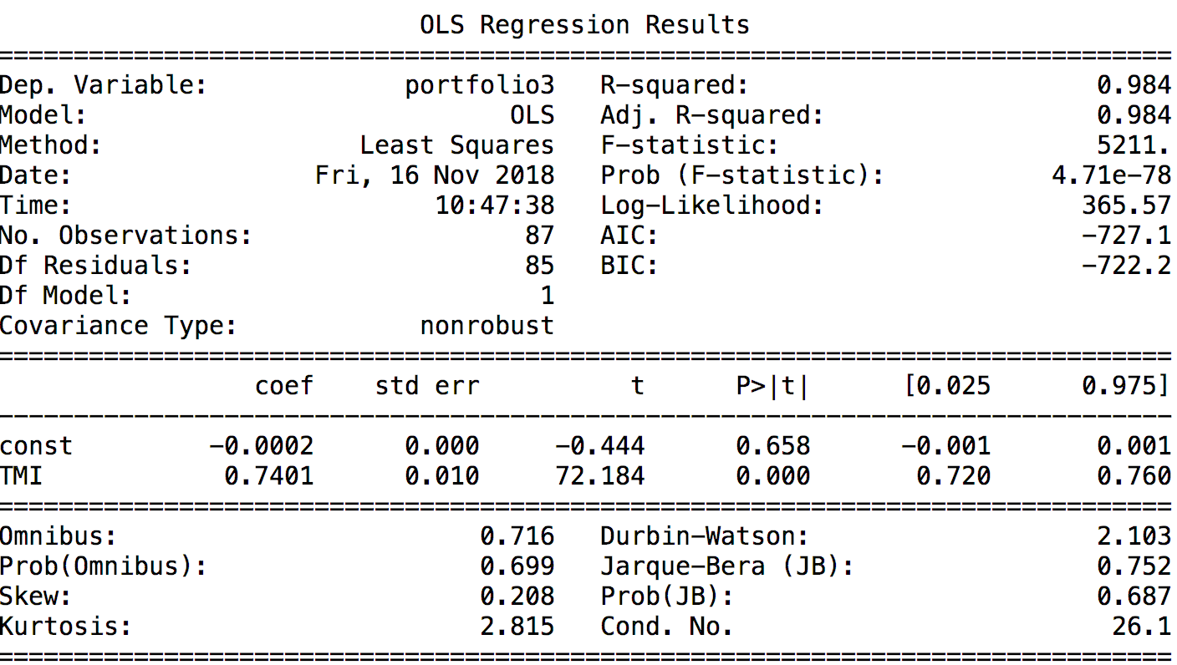

**Portfolio 4**

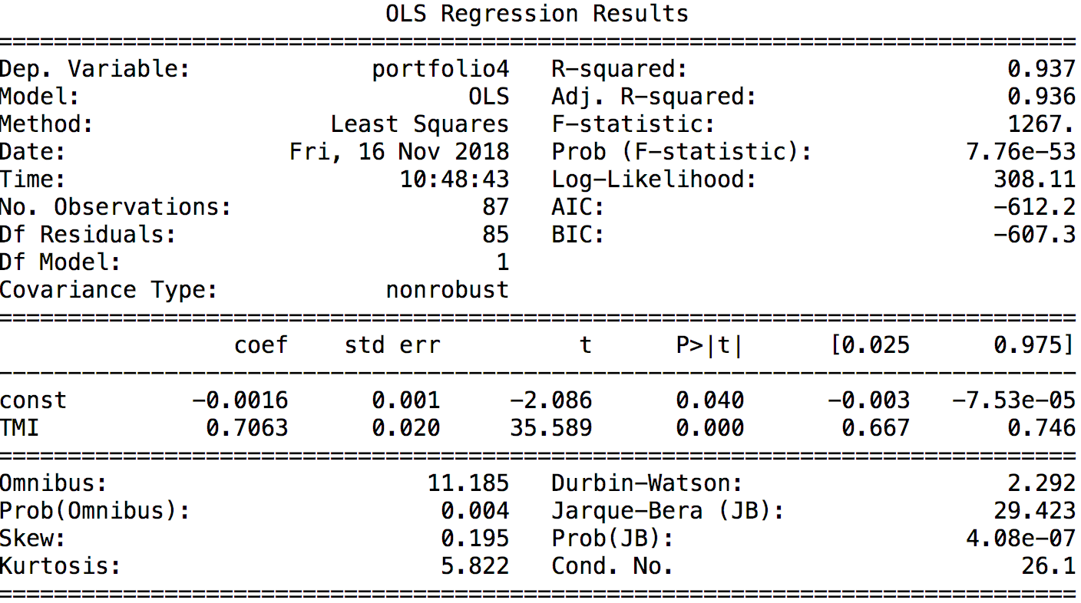

**Python Code**

*Title: Investment Case II  
# Author: Yang Chenyu  
# Number: 2016301550186  
# Date: 11/13/2018  
# I save the data I need as .csv in the Pycharm environment  
# All path is the project itself  
  
# import all the modules that I need***import** pandas **as** pd  
**import** numpy **as** np  
**import** matplotlib.pyplot **as** plt  
**import** statsmodels.api **as** sm  
  
*# Question 1--------------------------------------------*TMI = pd.read_csv(**'STOXX_TMI.csv'**).sort_index(ascending=**False**)  
TKA = pd.read_csv(**'TKA.csv'**).sort_index(ascending=**False**)  
OLE = pd.read_csv(**'OLE.csv'**).sort_index(ascending=**False**)  
  
*# Transfer the str into float*TMI[**'Return'**] = TMI[**'Return'**].str.strip(**'%'**).astype(float) / 100  
TKA[**'Return'**] = TKA[**'Return'**].str.strip(**'%'**).astype(float) / 100  
OLE[**'Return'**] = OLE[**'Return'**].str.strip(**'%'**).astype(float) / 100  
  
*# Calculate the risk of these three assets*TMI_risk = TMI[**'Return'**].std()  
TKA_risk = TKA[**'Return'**].std()  
OLE_risk = OLE[**'Return'**].std()  
  
*# Question 3--------------------------------------------*portion1 = np.array([0.35, 0.65]) *# risk-free, index*portion2 = np.array([0.3, 0.7]) *# risk-free, index*portion3 = np.array([0.3, 0.65, 0.05]) *# risk-free, index, TKA*portion4 = np.array([0.3, 0.65, 0.05]) *# risk-free, index, OLE*bond = pd.read_csv(**'German T-Bills.csv'**).sort_index(ascending=**False**)  
bond[**'Return'**] = bond[**'Return'**].str.strip(**'%'**).astype(float) / 100  
data = bond  
  
*# Merge different DataFrames to get a total data set of returns***for** i **in** [**'TMI'**, **'TKA'**, **'OLE'**]:  
 data = pd.merge(data, eval(i).iloc[:, [0, 2]], on=**'Date'**, how=**'outer'**)  
data.columns = [**'Date'**, **'Bond'**, **'TMI'**, **'TKA'**, **'OLE'**]  
  
*# Add the returns of different portfolios into the DataFrame*data[**'portfolio1'**] = (data.iloc[:, [1, 2]] * portion1).sum(axis=1)  
data[**'portfolio2'**] = (data.iloc[:, [1, 2]] * portion2).sum(axis=1)  
data[**'portfolio3'**] = (data.iloc[:, [1, 2, 3]] * portion3).sum(axis=1)  
data[**'portfolio4'**] = (data.iloc[:, [1, 2, 4]] * portion4).sum(axis=1)  
  
*# save this data for Problem 7*data_dat = data.copy()  
  
*# Calculate the risk of the 4 portfolios*port1_risk = data[**'portfolio1'**].std()  
port2_risk = data[**'portfolio2'**].std()  
port3_risk = data[**'portfolio3'**].std()  
port4_risk = data[**'portfolio4'**].std()  
  
*# Because the result is different from my prediction, I chose to calculate the correlations*data.iloc[:, 1:5].corr().to_csv(**'correlation.csv'**)  
  
*# Question 4--------------------------------------------  
  
# The data for this problem is this*data = data.iloc[:, :5]  
  
*# Get the excess return***for** i **in** range(2, 5):  
 data.iloc[:, i] = data.iloc[:, i] - data.iloc[:, 1]  
data = data.iloc[:, [0, 2, 3, 4]]  
  
*# Regression for TKA*Y_TKA = data.iloc[:, 2]  
X_TKA = data.iloc[:, 1]  
X_TKA = sm.add_constant(X_TKA)  
  
*# Use statsmodels to do the OLS rather than sklearn*model = sm.OLS(Y_TKA, X_TKA)  
results = model.fit()  
alpha, beta = results.params  
x_fit = np.array(X_TKA)  
y_fit = results.fittedvalues  
  
*# Calculate the total risk, system risk and nonmarket risk*total_risk_TKA = data.iloc[:, 2].std()  
sys_risk_TKA = beta * data.iloc[:, 1].std()  
nonsys_risk_TKA = (results.fittedvalues - Y_TKA).std()  
  
*# Plot for TKA*plt.scatter(data.iloc[:, 1], data.iloc[:, 2], c=**'r'**, label=**'Actual'**)  
plt.plot(x_fit[:, 1], y_fit, label=**'OLS'**, linewidth=2, c=**'b'**)  
plt.xlabel(**'TMI'**)  
plt.ylabel(**'TKA'**)  
plt.title(**'Single-Index Model for TKA'**)  
plt.xlim(-0.15, 0.15)  
plt.ylim(-0.4, 0.3)  
plt.grid()  
plt.legend()  
plt.show()  
  
*# Regression for OLE*Y_OLE = data.iloc[:, 3]  
X_OLE = data.iloc[:, 1]  
X_OLE = sm.add_constant(X_OLE)  
model = sm.OLS(Y_OLE, X_OLE)  
results = model.fit()  
alpha, beta = results.params  
x_fit = np.array(X_OLE)  
y_fit = results.fittedvalues  
  
*# Calculate the total risk, system risk and nonmarket risk*total_risk_OLE = data.iloc[:, 3].std()  
sys_risk_OLE = beta * data.iloc[:, 1].std()  
nonsys_risk_OLE = (results.fittedvalues - Y_OLE).std()  
  
*# Plot for OLE*plt.scatter(data.iloc[:, 1], data.iloc[:, 3], c=**'r'**, label=**'Actual'**)  
plt.plot(x_fit[:, 1], y_fit, label=**'OLS'**, linewidth=2, c=**'b'**)  
plt.xlabel(**'TMI'**)  
plt.ylabel(**'OLE'**)  
plt.title(**'Single-Index Model for OLE'**)  
plt.grid()  
plt.xlim(-0.15, 0.15)  
plt.ylim(-0.6, 0.6)  
plt.legend()  
plt.show()  
  
*# Question 7--------------------------------------------  
  
# deep copy in order to get original data*data = data_dat.copy()  
  
*# Generate Benchmark 40% bonds & 60% market index*benchmark = data.iloc[:, :3]  
benchmark[**'Benchmark'**] = (data.iloc[:, [1, 2]] * np.array([0.4, 0.6])).sum(axis=1) - benchmark[**'Bond'**]  
benchmark[**'TMI'**] = benchmark[**'TMI'**] - benchmark[**'Bond'**]  
benchmark = benchmark.iloc[:, [0, 2, 3]]  
  
*# OLS for benchmark*X_benchmark = benchmark.iloc[:, 1]  
X_benchmark = sm.add_constant(X_benchmark)  
Y_benchmark = benchmark.iloc[:, 2]  
results = sm.OLS(Y_benchmark, X_benchmark).fit()  
alpha_bench, beta_bench = results.params  
  
*# Calculate the total risk, system risk and nonmarket risk*total_risk_benchmark = benchmark.iloc[:, 2].std()  
sys_risk_benchmark = beta_bench * benchmark.iloc[:, 1].std()  
nonsys_risk_benchmark = (results.fittedvalues - Y_benchmark).std()  
  
*# Generate the excess return of portfolios*data.iloc[:, 2] = data.iloc[:, 2] - data.iloc[:, 1]  
**for** i **in** range(5, 9):  
 data.iloc[:, i] = data.iloc[:, i] - data.iloc[:, 1]  
data = data.iloc[:, [0, 2, 5, 6, 7, 8]]  
  
*# Portfolio 1*Y_p1 = data.iloc[:, 2]  
X_p1 = data.iloc[:, 1]  
X_p1 = sm.add_constant(X_p1)  
model = sm.OLS(Y_p1, X_p1)  
results = model.fit()  
alpha_p1, beta_p1 = results.params  
  
*# Calculate the total risk, system risk and nonmarket risk*total_risk_p1 = data.iloc[:, 2].std()  
sys_risk_p1 = beta_p1 * data.iloc[:, 1].std()  
nonsys_risk_p1 = (results.fittedvalues - Y_p1).std()  
  
*# Portfolio 2*Y_p2 = data.iloc[:, 3]  
X_p2 = data.iloc[:, 1]  
X_p2 = sm.add_constant(X_p2)  
model = sm.OLS(Y_p2, X_p2)  
results = model.fit()  
alpha_p2, beta_p2 = results.params  
  
*# Calculate the total risk, system risk and nonmarket risk*total_risk_p2 = data.iloc[:, 3].std()  
sys_risk_p2 = beta_p2 * data.iloc[:, 1].std()  
nonsys_risk_p2 = (results.fittedvalues - Y_p2).std()  
  
*# Portfolio 3*Y_p3 = data.iloc[:, 4]  
X_p3 = data.iloc[:, 1]  
X_p3 = sm.add_constant(X_p3)  
model = sm.OLS(Y_p3, X_p3)  
results = model.fit()  
alpha_p3, beta_p3 = results.params  
  
*# Calculate the total risk, system risk and nonmarket risk*total_risk_p3 = data.iloc[:, 4].std()  
sys_risk_p3 = beta_p3 * data.iloc[:, 1].std()  
nonsys_risk_p3 = (results.fittedvalues - Y_p3).std()  
  
*# Portfolio 4*Y_p4 = data.iloc[:, 5]  
X_p4 = data.iloc[:, 1]  
X_p4 = sm.add_constant(X_p4)  
model = sm.OLS(Y_p4, X_p4)  
results = model.fit()  
alpha_p4, beta_p4 = results.params  
  
*# Calculate the total risk, system risk and nonmarket risk*total_risk_p4 = data.iloc[:, 5].std()  
sys_risk_p4 = beta_p4 * data.iloc[:, 1].std()  
nonsys_risk_p4 = (results.fittedvalues - Y_p4).std()  
  
  
*# Problem 9*data = data_dat.copy()  
*# Remove the data of 2018*data = data[data[**'Date'**].apply(**lambda** x:**False if** x.__contains__(**'2008'**) **else True**)]  
  
*# Generate Benchmark 40% bonds & 60% market index*benchmark = data.iloc[:, :3]  
benchmark[**'Benchmark'**] = (data.iloc[:, [1, 2]] * np.array([0.4, 0.6])).sum(axis=1) - benchmark[**'Bond'**]  
benchmark[**'TMI'**] = benchmark[**'TMI'**] - benchmark[**'Bond'**]  
benchmark = benchmark.iloc[:, [0, 2, 3]]  
  
*# OLS for benchmark*X_benchmark = benchmark.iloc[:, 1]  
X_benchmark = sm.add_constant(X_benchmark)  
Y_benchmark = benchmark.iloc[:, 2]  
results = sm.OLS(Y_benchmark, X_benchmark).fit()  
alpha_bench, beta_bench = results.params  
  
*# Calculate the total risk, system risk and nonmarket risk*total_risk_benchmark = benchmark.iloc[:, 2].std()  
sys_risk_benchmark = beta_bench * benchmark.iloc[:, 1].std()  
nonsys_risk_benchmark = (results.fittedvalues - Y_benchmark).std()  
  
*# Generate the excess return of portfolios*data.iloc[:, 2] = data.iloc[:, 2] - data.iloc[:, 1]  
**for** i **in** range(5, 9):  
 data.iloc[:, i] = data.iloc[:, i] - data.iloc[:, 1]  
data = data.iloc[:, [0, 2, 5, 6, 7, 8]]  
  
*# Portfolio 1*Y_p1 = data.iloc[:, 2]  
X_p1 = data.iloc[:, 1]  
X_p1 = sm.add_constant(X_p1)  
model = sm.OLS(Y_p1, X_p1)  
results = model.fit()  
alpha_p1, beta_p1 = results.params  
  
*# Calculate the total risk, system risk and nonmarket risk*total_risk_p1 = data.iloc[:, 2].std()  
sys_risk_p1 = beta_p1 * data.iloc[:, 1].std()  
nonsys_risk_p1 = (results.fittedvalues - Y_p1).std()  
  
*# Portfolio 2*Y_p2 = data.iloc[:, 3]  
X_p2 = data.iloc[:, 1]  
X_p2 = sm.add_constant(X_p2)  
model = sm.OLS(Y_p2, X_p2)  
results = model.fit()  
alpha_p2, beta_p2 = results.params  
  
*# Calculate the total risk, system risk and nonmarket risk*total_risk_p2 = data.iloc[:, 3].std()  
sys_risk_p2 = beta_p2 * data.iloc[:, 1].std()  
nonsys_risk_p2 = (results.fittedvalues - Y_p2).std()  
  
*# Portfolio 3*Y_p3 = data.iloc[:, 4]  
X_p3 = data.iloc[:, 1]  
X_p3 = sm.add_constant(X_p3)  
model = sm.OLS(Y_p3, X_p3)  
results = model.fit()  
alpha_p3, beta_p3 = results.params  
  
*# Calculate the total risk, system risk and nonmarket risk*total_risk_p3 = data.iloc[:, 4].std()  
sys_risk_p3 = beta_p3 * data.iloc[:, 1].std()  
nonsys_risk_p3 = (results.fittedvalues - Y_p3).std()  
  
*# Portfolio 4*Y_p4 = data.iloc[:, 5]  
X_p4 = data.iloc[:, 1]  
X_p4 = sm.add_constant(X_p4)  
model = sm.OLS(Y_p4, X_p4)  
results = model.fit()  
alpha_p4, beta_p4 = results.params  
  
*# Calculate the total risk, system risk and nonmarket risk*total_risk_p4 = data.iloc[:, 5].std()  
sys_risk_p4 = beta_p4 * data.iloc[:, 1].std()  
nonsys_risk_p4 = (results.fittedvalues - Y_p4).std()